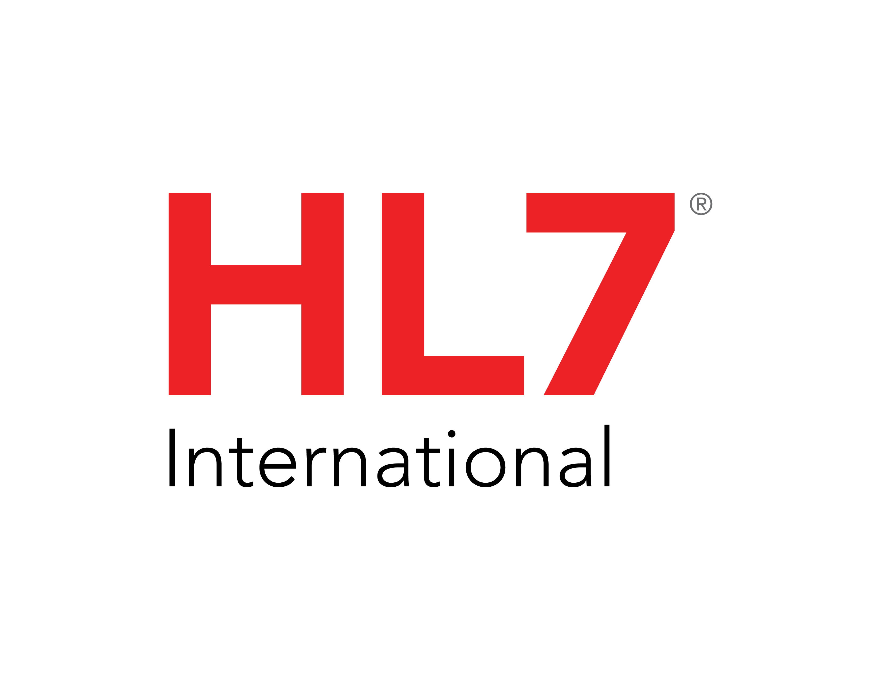

Daniel Vreeman

HL7 Chief Standards Development Officer (CSDO)

Health Level Seven International

3300 Washtenaw Avenue, Suite 227

Ann Arbor, MI 48104

December xx, 2022

Dear HL7 Member,

The Clinical Quality Information Work Group has asked me to forward you a set of recommended corrections and modifications to the "**HL7 CDA R2 Implementation Guide: Quality Reporting Document Architecture Category I (QRDA I), Release 1 - STU Release 5.3 - US Realm**” (HL7 QRDA I R1 STU5.3). The referenced document can be found on the HL7 Web site at the following location:

<http://www.hl7.org/implement/standards/product_brief.cfm?product_id=35>.

An updated errata package has been produced which 1) corrects QRDA I STU5.3 issues reported through HL7 Jira tracking system (jira.hl7.org) and are with approved resolution as resolved – change required and 2) incorporates

HL7 Implementation Guide for CDA® Release 2: Consolidated CDA Templates for Clinical Notes (US Realm) Draft Standard for Trial Use Release 2.1, September 2022 Errata Release #7 that are relevant to QRDA I STU5.3. For a detailed list of errata, see the attached file: 2022DEC_QRDA_I_R1_STU5.3_Errata_List.xlsx.

|  |  |
| --- | --- |
| The errata package contains: | |
| File Name | Description |
| _readme.txt | Updated readme |
| 2022DEC_QRDA_I_R1_STU5.3_Errata_List.xlsx. | This list of errata included in this errata notification |
| CDAR2_IG_QRDA_I_R1_STU5.3_2021NOV_Vol1_2022DEC_with_errata.pdf | Updated volume 1 from November 2021 initial publication |
| CDAR2_IG_QRDA_I_R1_STU5.3_2021NOV_Vol2_2022DEC_with_errata.pdf | Updated volume 2 from November 2021 initial publication |

Sincerely,

Daniel Vreeman

HL7 CSDO